Replicate s3 bucket from one bucket to another bucket of different accounts

Create a user gaurav in destination account

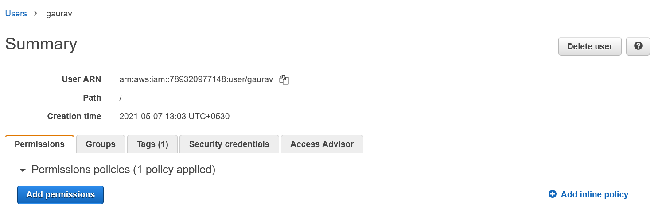

Create a bucket in source account, and upload files to it.

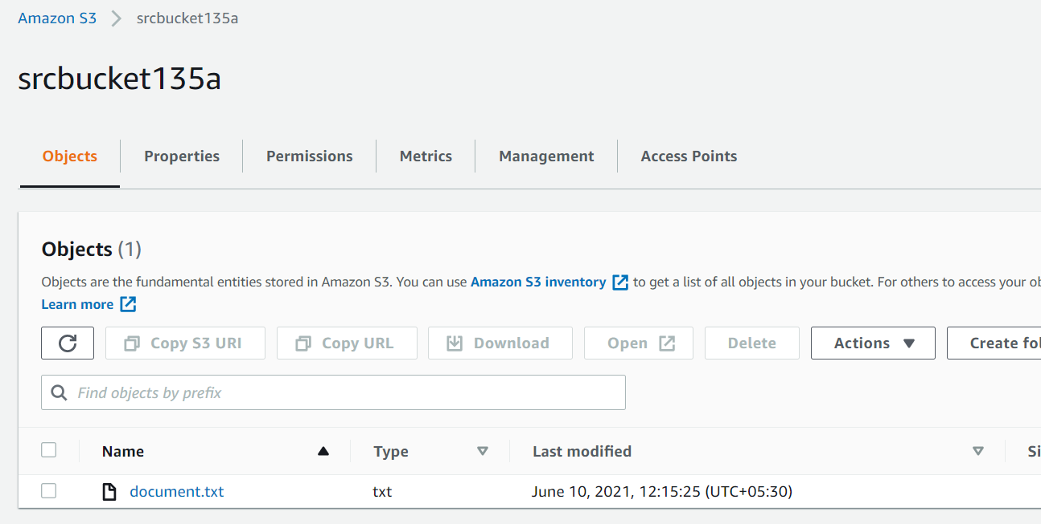

Go to policy generator and generate desired policy.

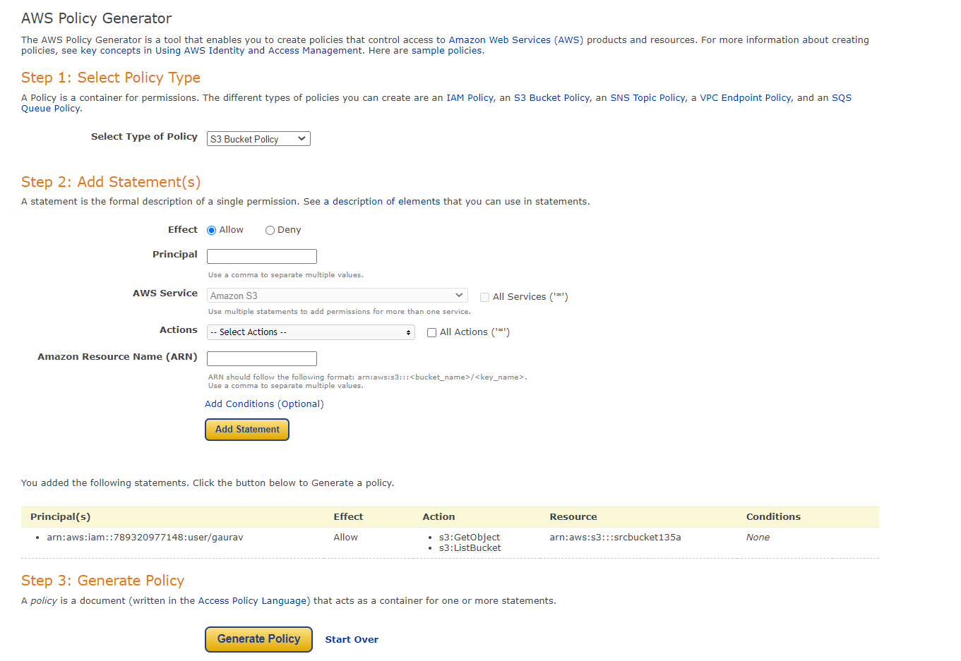

The policy is generated

{

"Id": "Policy1623304755314",

"Version": "2012-10-17",

"Statement": [

{

"Sid": "Stmt1623304734065",

"Action": [

"s3:GetObject",

"s3:ListBucket"

],

"Effect": "Allow",

"Resource": [

"arn:aws:s3:::srcbucket135a",

"arn:aws:s3:::srcbucket135a/\*"

]

"Principal": {

"AWS": [

"arn:aws:iam::789320977148:user/gaurav"

]

}

}

]

}

Now go to destination account

Create a policy to assign it to user gaurav

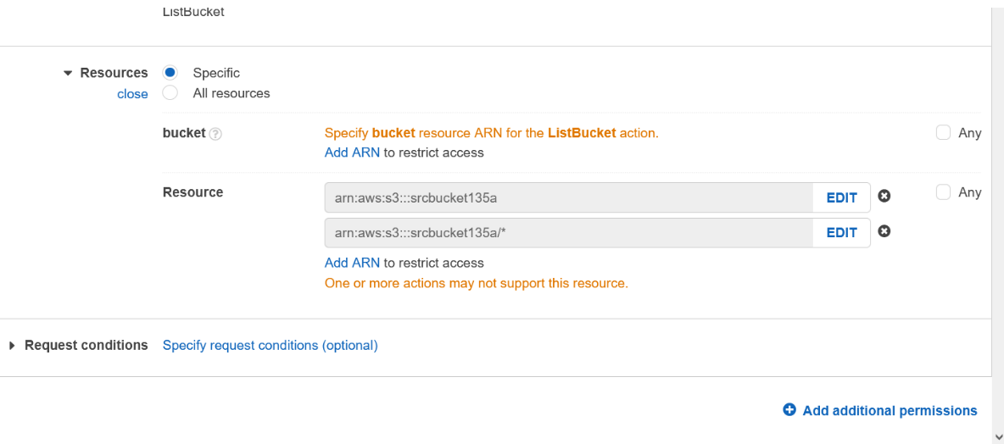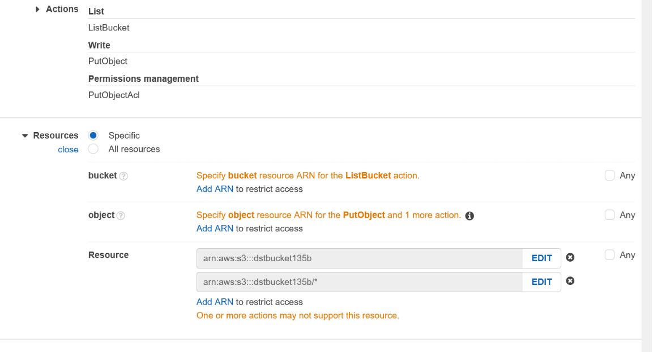

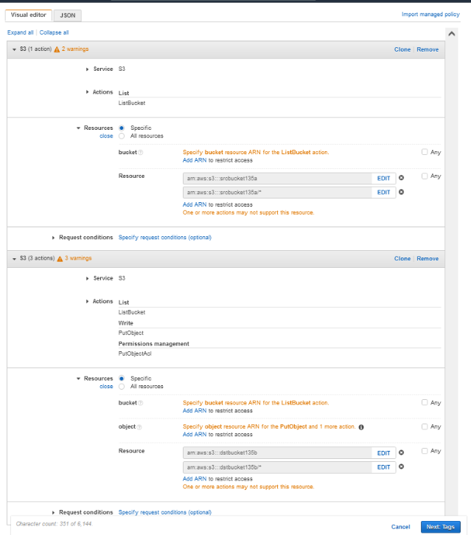

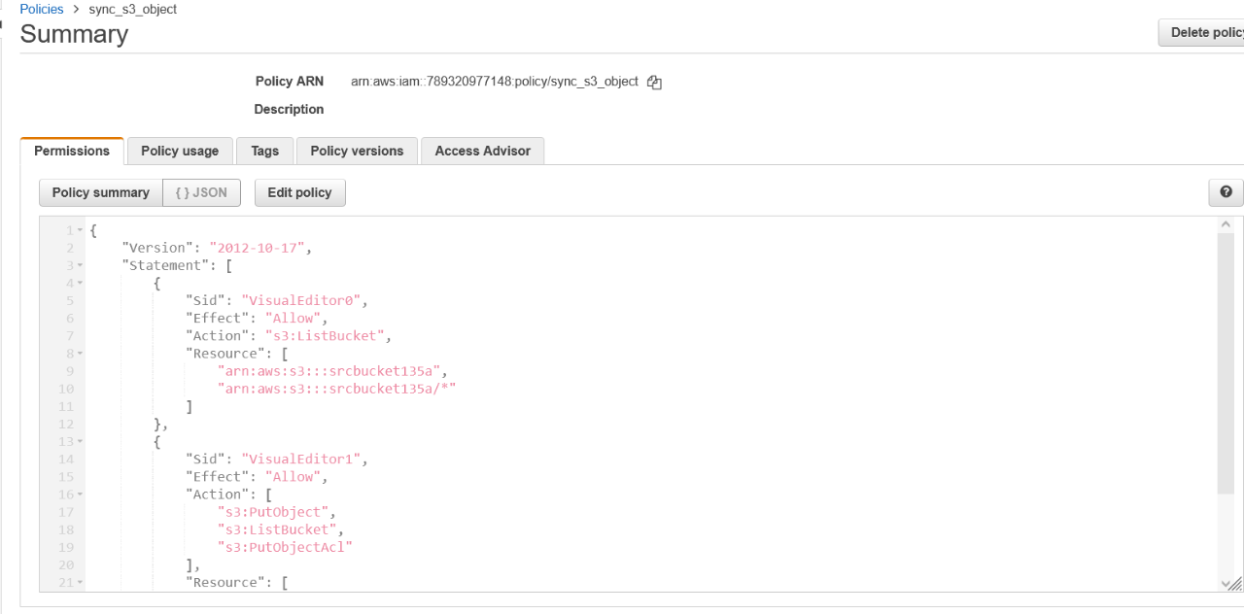

Attcach the policy to user gaurav.

{

"Version": "2012-10-17",

"Statement": [

{

"Sid": "VisualEditor0",

"Effect": "Allow",

"Action": "s3:ListBucket",

"Resource": [

"arn:aws:s3:::srcbucket135a",

"arn:aws:s3:::srcbucket135a/\*"

]

},

{

"Sid": "VisualEditor1",

"Effect": "Allow",

"Action": [

"s3:PutObject",

"s3:ListBucket",

"s3:PutObjectAcl"

],

"Resource": [

"arn:aws:s3:::dstbucket135b",

"arn:aws:s3:::dstbucket135b/\*"

]

}

]

}

Create distination bucket in the destination account.

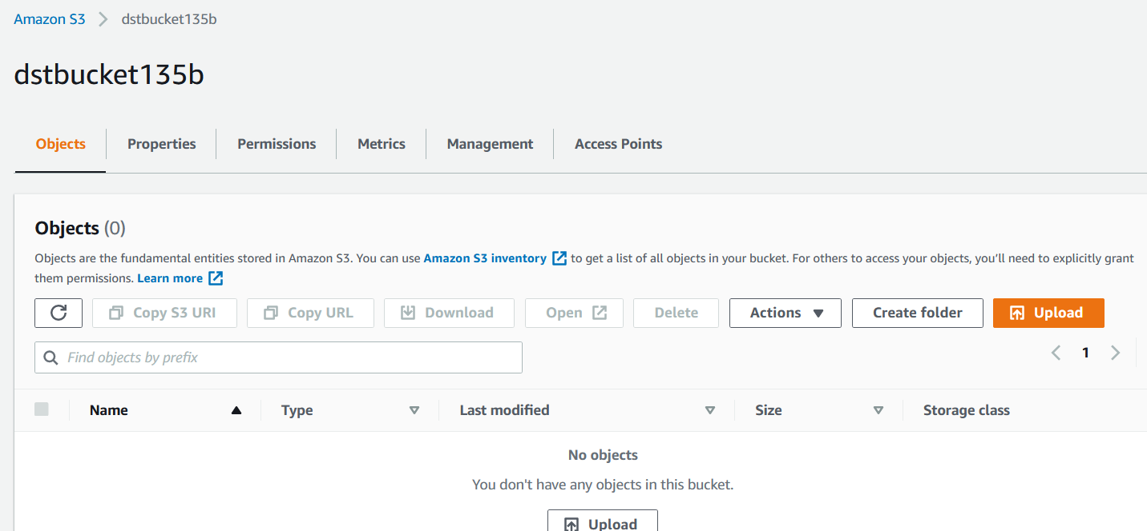

Now run the below command to aws cli to sync both the buckets

aws s3 sync s3://srcbucket135a s3://dstbucket135b

The file is successfully copied to destination aws account

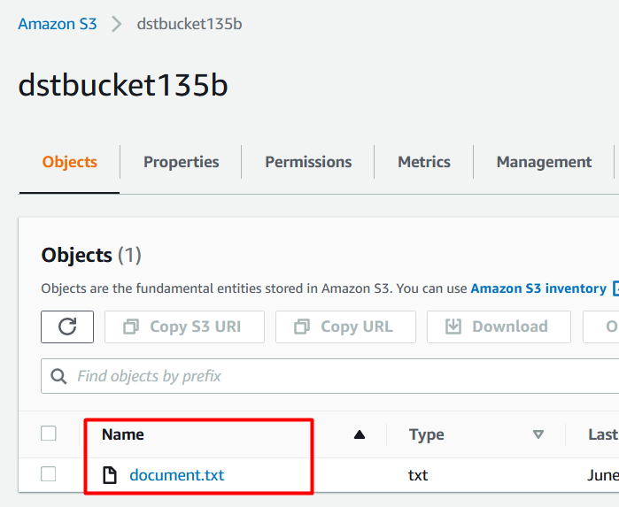

Hence our goal for this is achieved.